Manuscripts are submitted online exclusively at the following address:
https://conferences.ufzg.hr/ojs/index.php/STOO_4 , in a single Open Office or Microsoft Word document in Croatian or English. 3rd International Scientific and Art Faculty of Teacher Education University of Zagreb Conference – Contemporary Themes in Education – CTE4 – uses the APA system of reference (Publication Manual of the American Psychological Association, 7th ed., 2020).

CTE4 Conference
26th – 27th September 2024 / Zagreb, Croatia

Paper Title - type here the title of your paper [Centred, Calibri, sentence case, font size 14 points, bold]

Abstract [Left, Calibri, font size 12 points, bold]
Abstract should have up to 1800 characters with spaces, Calibri, font size 11 points. The text should indicate the context of the work, its main objective, sample, methods, results and conclusion of the paper.
After the abstract, write the Key words - an alphabetized list of the most important concepts discussed in the paper, up to five terms not mentioned in the title of the paper and separated with a semi colon (;).
Key words [Left, Calibri, font size 11 points, bold, italics]: alphabetized first term; alphabetized second term; alphabetized third term; alphabetized fourth term; alphabetized fifth term

Subtitle [First level subtitle - Left, Calibri, font size 12 points, bold]
Papers are submitted in the following format: A4 format, 3 cm margins, font size 11 points, Calibri, single spaced (1.0). Headers and footers are not allowed, still, footnotes are not recommended. For emphasis italics are recommended instead of underlining. Do not number pages, as page numbers will be added later in the publication process.
The text of the scientific research paper should basically consist of the following sections: Introduction, Methods, Results, Discussion, Conclusions and References.
Authors take full responsibility for the language quality of the text. The total length of the manuscript should not exceed 20 standard pages (including references and all figures and tables). Standard page size is 1800 characters with spaces. Manuscripts are submitted online exclusively at the following address: https://conferences.ufzg.hr/ojs/index.php/STOO_4 , in a single Open Office or Microsoft Word document.
Paragraph line spacing single, alignment justified, indentation (1.0pt), no before-after spacing, do not leave an empty line between paragraphs.
Subtitles should not be numbered, sentence case, font size 12 points, Calibri, bold with one empty line above the subtitle and no empty line below the subtitle. Subtitles should not be numbered. Examples of subtitles by levels of importance as follows:

First level subtitle [Left, Calibri, font size 12 points, bold]
Please insert text of your paper. Leave one empty line above the subtitle and no empty line below the subtitle.

Second level subtitle [Left, Calibri, font size 11 points, italic, bold]
Please insert text of your paper. Before subtitle, please leave one empty line above the subtitle and no empty line below the subtitle.

Third level subtitle [Left, Calibri, font size 11 points, bold]
Please insert text of your paper. Before subtitle, please leave one empty line above the subtitle and no empty line below the subtitle.

Graphs, figures and tables
All graphs, figures and tables should have a title, be numbered in the order in which they appear in the text (e.g. Table 1) and should be referred to in the text. All tables and figures should be numbered sequentially with Arabic numerals as they are referred to in the text.
Tables and figures, titles and captions should be centred, single spaced, font Calibri, 10pt, placed above the tables and underneath the graphs and figures.
Graphs, figures and tables should be black, white and grey, high-quality and print-ready, as well as positioned in the appropriate place within the text, never exceeding the paper margins. Do not send tables as pictures and do not “lock” the illustrations.
All graphs, figures and tables should be created according to the APA Publication Manual – (Publication Manual of the American Psychological Association, 7th ed., 2020).

Table 1
Table title
Semester | Number of students | Percentage
First | 80 | 27,59
Second | 75 | 25,86
Third | 70 | 24,14
Fourth | 65 | 22,41
SUM | 290 | 100,00
Note.

Figure 1
Figure title
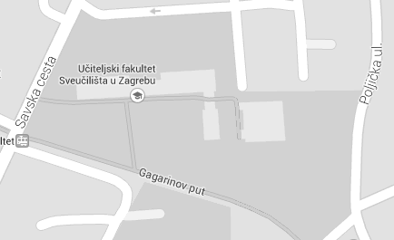
Note.

Figure 2
Figure title
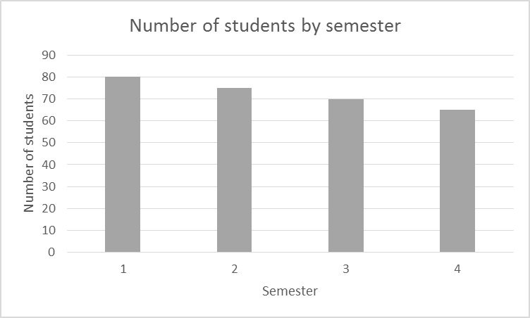
Note.

Statistics
When reporting on statistics, sufficient information necessary for full understanding of the conducted analysis must be included. Greek letters, subscripts and superscripts that function as identifiers and abbreviations that are not variables are set in regular font style, and all other statistical symbols in italic.
Use the decimal point, not a comma. Use a zero before the decimal point with numbers that are less than 1 when statistics can exceed 1. Do not use a zero before a decimal fraction when the statistics cannot be greater than 1. Round the decimals as much as possible, while keeping prospective use and statistical precision in mind. For further instructions and examples, please consult the APA Publication Manual.

Citations and References
3rd International Scientific and Art Faculty of Teacher Education University of Zagreb Conference – Contemporary Themes in Education – CTE – uses the APA system of reference (Publication Manual of the American Psychological Association, 7th ed., 2020). Unless the referencing is in accordance with the APA style, the paper will be returned to the author prior to the reviewing procedure.

In-text citations
When syntagms, ideas, data, terms, etc. by other authors are cited, the source should be given in the text and not in the footnotes. References are given in brackets and should contain the author’s surname, the year of publication and, in case of a verbatim quotation, the page number (e.g. Vilke, 1993, pp. 23-26; Rossi & Cassidy, 1999, p.24). For a work with one or two authors, include the author name(s) in every citation (e.g. Salas & D’Agostino, 2020). For a work with three or more authors, include the name of only the first author plus “et al.” in every citation, including the first citation, unless doing so would create ambiguity (Seligman et al., 2020). When paraphrasing, the author's name should be written and the year of publication given in brackets (e.g. Horvat (2001) claims that …; Zarevski and Tominac (2008) maintain...).

List of references
The paper should include references and sources on the basis of which it was written, without bullets or numbering and with 1.0 indentation (justified alignment).
The reference list at the end of the paper (References) should include full information about all the works that are referenced in the paper, in alphabetical order according to the author’s surname (the works of the same author should be listed chronologically), Latin alphabet. The titles in the reference list need to be given in the language of the original, and if they have been translated into English, the English translation should be given in square brackets [ ]. When electronic sources are referenced, the date of retrieval must be stated.

References
Examples of referencing:

Articles published in journals:
McCauley, S. M., & Christiansen, M. H. (2019). Language learning as language use: A cross-linguistic model of child language development. Psychological Review, 126(1), 1–51. https://doi.org/10.1037/rev0000126

Books:
Rosandić, D. (1993). Novi metodički obzori. Zagreb: Školske novine.
Hardy, C., & Mawer, M. (1999). Learning and teaching in physical education. London: Falmer Press.

Chapters in books:
Rossi, T., & Cassidy, T. (1999). Knowledgeable Teachers in Physical Education: A view of teachers’ knowledge. In C. Hardy & M. Mawer (Eds.), Learning and teaching in physical education (pp. 188-202). London: Falmer Press.

Conference Proceedings:
Bežen, A. (2004). Ekološki odgoj i kroatistika. In S. Golac (Ed.), Ekologija u odgoju i obrazovanju (pp. 90 – 102). Gospić: Visoka učiteljska škola.
Prskalo, I., Jenko, S., & Horvat, V. (2008). Differences in some anthropometric characteristics and motor skills in boys from Great Britain and Croatia. In D. Milanović, & F. Prot (Eds.), 5th International Scientific Conference on Kinesiology - Kinesiology research trends and applications (pp. 521-524). Zagreb: Faculty of Kinesiology, University of Zagreb.

Doctoral dissertation or Master’s thesis:
Gruić, I. (2005). Entering the story labyrinth. An Investigation of the Effects of Placing the Participants in Different Actantial Positions within the Dramatic World Created by a Theatre in Education Programme. [Doctoral disertation or Master’s thesis]. Birmingham: Faculty of Education University of Central England in Birmingham.

Electronic sources:
UNESCO (1995-2008). Quality Physical Education. Retrieved on 10th September 2024, from http://portal.unesco.org/en/ev.phpURL=201.html

CTE4 Conference
26th – 27th September 2024 / Zagreb, Croatia

Naslov rada – unesite naslov rada [centrirano, Calibri, pisana slova, veličina slova 14, podebljano]

Sažetak [Lijevo, Calibri, veličina slova 12, podebljano]
Sažetak može sadržavati do 1800 znakova s prazninama, Calibri, veličina slova 11. Tekst treba uputiti na svrhu rada, najvažnije rezultate, uzorak, korištene metode, rezultate i zaključak.
Na kraju sažetka pod oznakom Ključne riječi treba abecednim redom navesti najvažnije pojmove koji se obrađuju u tekstu (do pet pojmova abecednim redom koji se ne spominju u naslovu rada, odvojenih točka sa zarezom (;).
Ključne riječi [lijevo poravnavanje, Calibri, veličina slova 11, podebljano, kurziv]: abecednim redom prvi pojam; drugi pojam; treći pojam; četvrti pojam; peti pojam

